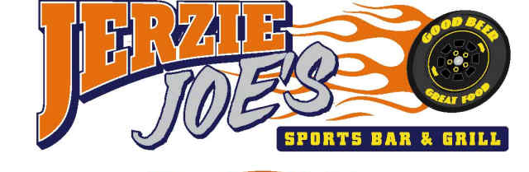



Saint Patrick’s DAY

 3-17-17

**FROM THE KITCHEN**

**WOW: WING OF THE WEEK “KILLIANS IRISH”**

* **Corned Beef Hash Omelet: with Irish sausage & rye toast 8.50**
* **Corned Beef Hash n’ Eggs: with Irish sausage & rye toast 8.00**
* **Corned Beef Hash Rolls: with a sweet dipping sauce 6.75**
* **Bangers n’ Mash: green beans, house salad & HP Sauce 10.95**
* **Reuben: rye toast, sauerkraut, Swiss, dressing and fries $8.95**
* **Corned Beef & Cabbage with potatoes and carrots $15.95**
* **Irish Stew: served with bread n’ butter Crock 5.95 Bowl 8.95**

 OFFERS GOOD WHILE SUPPLIES LAST

**JERZIE JOES.COM**